**Complaints Form**



If you want to make a complaint about Ark you can use this form. You can write what you want to tell us here.



You can also make a complaint without telling us who you are.

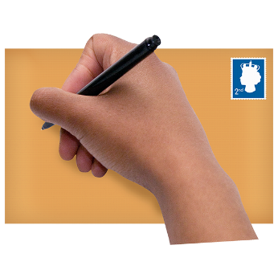Please write clearly and send your form to:

**Ark  
Ground Floor, West Suite,**

**Lochside House  
3 Lochside Way, Edinburgh Park**

**EH12 9DT**

complaints@arkha.org.uk



**Your name:**

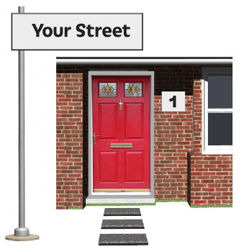**Your address:**

**Postcode:**

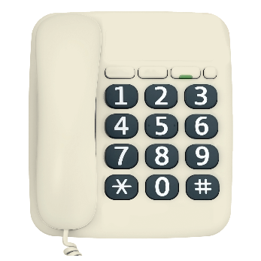

**Telephone number:**

**Please tell us as much as you can about your complaint:**



**What would you like us to do to sort it?**



**Signature:**

**Date:**

**What if I am still unhappy?**

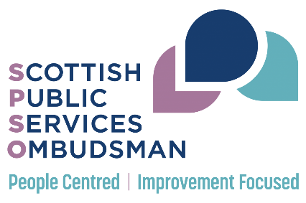If you made a complaint to us and are still unhappy after we give you our response, you can contact the **Scottish Public Services Ombudsman (SPSO)**.



By post: Freepost SPSO

(This is all you need to write on the envelope, and you don't need to use a stamp)



Freephone: 0800 377 7330



Website:

[www.spso.org.uk/contact-us](http://www.spso.org.uk/contact-us)

