**Complaints Guide**



We want to give you a good service.

If something goes wrong or you are not happy with our services, please tell us. **This guide tells you how to make a complaint and what we will do.**

**What is a complaint?**



If you are not happy about the service we provided, we call this **a complaint**.

These are some things you can complain about:

* How staff support you
* If we do not reply to your questions
* If we do not give you information
* Repairs taking a long time

**What can’t I complain about?**

There are some things that are not complaints:

* If you ask us to do something for the first time
* If the issue is being looked in court or in a tribunal.
* If we have already looked at the issue.

**Who can complain?**

Anyone can make a complaint to Ark, including a friend who wants to complain on your behalf. They will need your written permission.

Please also read the section on **getting help to make your complaint** on page 9.

**How do I complain?**



**Speak to a member of our staff.**

You can do it in person, by phone, in writing, by email or using our online form:

www.arkha.org.uk/contact-us/



It is easier if you speak directly to the service concerned.

Please tell us:

* your full name and contact details
* as much as you can about the issue
* what has gone wrong
* what you wish to happen

**How long do I have to make a complaint?**

You must make your complaint within 6 months of:

* the event you want to complain about; or
* finding out that you have a reason to complain



We may be able to accept a complaint after 6 months. If you feel that the time limit should not apply to you, please tell us why.

**What happens when I have complained?**



We will always tell you who is dealing with your complaint.

Our complaints procedure has 2 stages.



**Stage 1: Frontline response**

We want to sort things out quickly. For example we might apologise and explain why something has gone wrong, or we could do something to fix the problem.

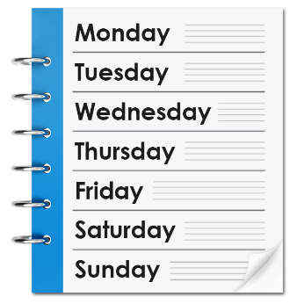

We will give you our response in 5 working days or less.



If you are not happy with our response, we will tell you what you can do next. You can choose to take your complaint to stage 2.

**Stage 2: Investigation**

At this stage we deal with 2 kinds of complaints:

* Complaints that were not sorted at stage 1, and
* Complaints that are more difficult and need more time.

At stage 2 we will:

* 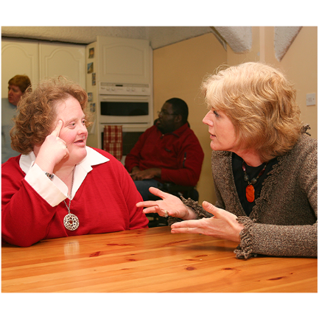Tell you we have received your complaint within 3 days.
* Talk to you about your complaint to make sure we understand why you are not happy.
* Reply to your complaint within 20 working days.

**What if I am still unhappy?**



If you are still unhappy after we give you our final decision or if you did not like the way we dealt with your complaint, you can ask the **Scottish Public Services Ombudsman (SPSO)** to look at it.

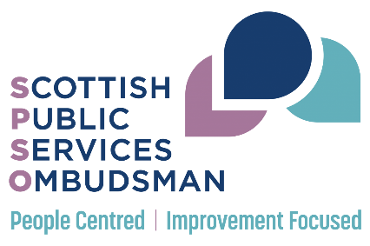

The SPSO are an independent organisation that look at complaints. They are **not** an advocacy or support service.

The SPSO will ask you to complete a complaint form and provide a copy of our final response to your complaint.

You can do this online at [www.spso.org.uk/complain/form](http://www.spso.org.uk/complain/form)

Or call them on Freephone 0800 377 7330.

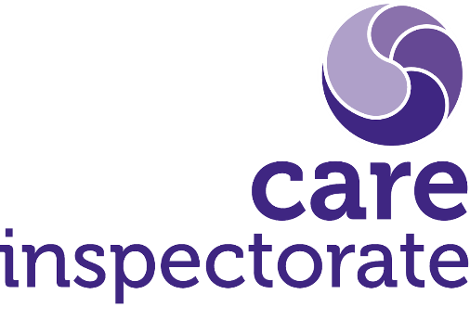**Care complaints**

If your complaint is about our care service, you can choose to complain to the Care Inspectorate: [www.careinspectorate.com](http://www.careinspectorate.com)

**Housing complaints**

The Scottish Housing Regulator (SHR) only looks at issues that are **‘significant performance failures’**.

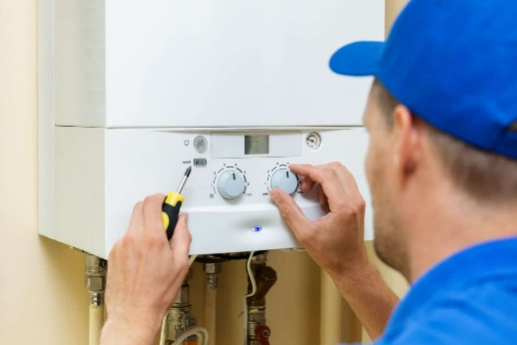This is something that a landlord does or fails to do that puts all the tenants at risk. For example not carrying out the annual gas check for our properties would be a significant performance failure.



If you have a problem like this, you should first tell us. If we have not sort it, you can report it to the SHR.

A complaint between an individual tenant and Ark is **not** a significant performance failure.

[www.scottishhousingregulator.gov.uk](http://www.scottishhousingregulator.gov.uk)

**Getting help to make your complaint**



We know that it might be difficult for you to make a complaint.

You can ask a friend, relative, or an advocate, to complain for you.

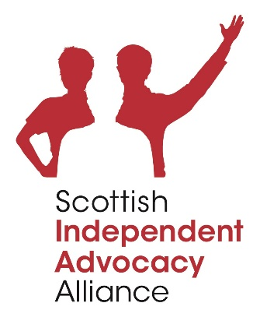You can find an advocate in your area by contacting the Scottish Independent Advocacy Alliance:

0131 510 9410

[www.siaa.org.uk](http://www.siaa.org.uk)

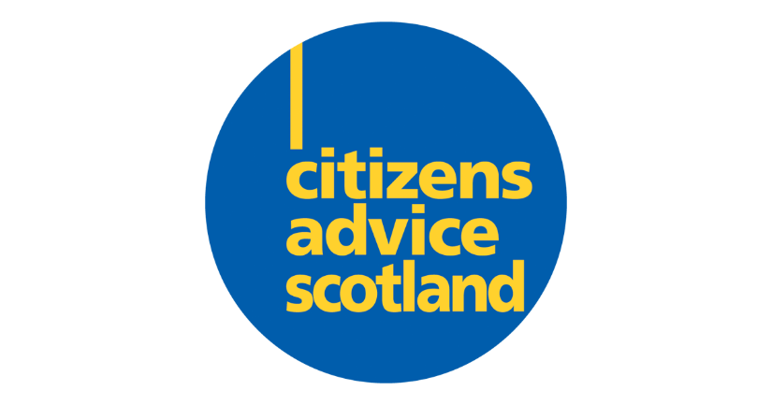

You can find advisers in your area through Citizens Advice Scotland:

[www.cas.org.uk](http://www.cas.org.uk)

**Our contact details**

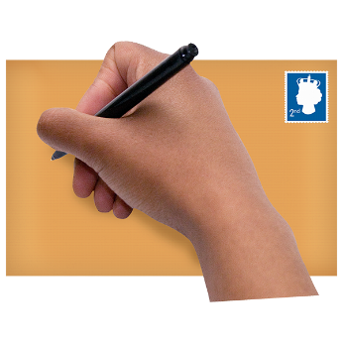

Ark

Ground Floor, West Suite,

Lochside House  
3 Lochside Way, Edinburgh Park EH12 9DT



complaints@arkha.org.uk



0131 447 9027

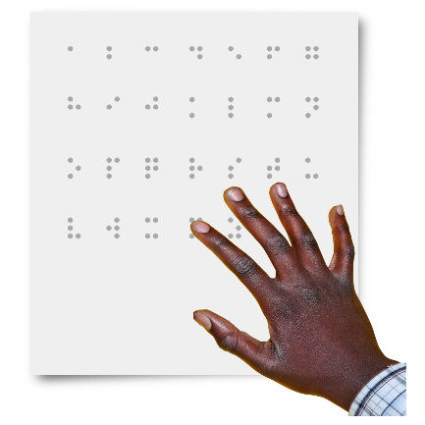

We can also give you this guide in other languages and formats (for example audio and Braille).